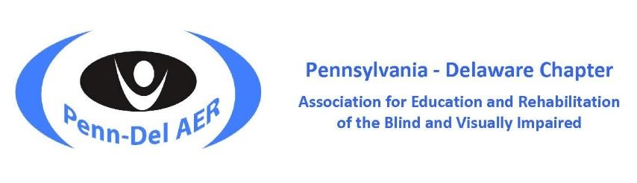

2023 Penn-Del AER Student Scholarship Invitation
The Penn-Del Chapter of AER is pleased to announce the 2023 Student Scholarship Award for a student member of the Penn-Del AER Chapter. A worthy student recipient will be awarded $1000 and a voucher to cover the transitional year for AER membership. This is an amazing opportunity, why not consider applying …
The Student Scholarship Award will be presented during the annual Penn-Del AER Conference. Recipients will be recognized at the Awards Banquet on Thursday evening, April 20, 2023.
Picture yourself being the next recipient of a $1000 scholarship award to use toward your educational expenses!
… because it could be YOU!
This opportunity is available to current student members of Penn-Del AER. If you are not a member, becoming one is an easy process that starts your connection and involvement in our professional organization. A small fee that is well-worth the chance of being awarded a student scholarship! Here is the link to AER Membership.
You ask, “What is AER?”
AER stands for the Association for Education and Rehabilitation of the Blind and Visually Impaired. AER is a not-for-profit membership organization dedicated exclusively to professionals who provide services to persons with vision loss.
The mission of AER is to serve and empower professionals to deliver standards-based practices that lead to improved educational and rehabilitative outcomes for individuals with visual impairment and blindness. AER promotes and supports professionals by advocating for evidence-based practices, high quality standards, value-added resources and gives voice to issues of critical importance. AER provides professional development via face-to-face conferences, virtual offerings and publications to strengthen the knowledge, skills and abilities of professionals within the field. AER provides networking, mentoring, connectivity, awards and scholarships for professionals to advance excellence within the field. Our aim is to ensure that persons with vision loss will have optimal gains and greater independence by giving timely, intentional, and value-added support to professionals in the field.
Membership Fee Structure:
- Student Membership is $98 per year (undergraduate or graduate).
- Transition Membership is $144 per year to support your continued membership through your first year as a professional.
- Regular Membership begins during your second year of teaching and is currently $175 per year.
To learn more about AER International, go to AER.
As the next generation of professionals in a low incidence field, your membership in AER is valued and needed. AER embodies a community of professionals to preserve the integrity of the delivery of services in the field of blindness and visual impairment.
Penn-Del AER is a chapter within AER representing professionals in Pennsylvania and Delaware. To view the activity of our local chapter, go to: Penn-Del AER, Facebook, or Twitter.
The Penn-Del AER Awards Committee looks forward to reviewing YOUR submission for scholarship consideration!
Scroll down for Student Scholarship Application Preparation and Submission Details. The Student Scholarship Application Cover Page is a separate document.
Regards,
Brenda Egan
Penn-Del AER Board of Directors
Awards Committee, Chair
The Pennsylvania-Delaware Chapter of the Association for Education and Rehabilitation of the Blind and Visually Impaired (AER) supports professionals who provide education & rehabilitation services to people with visual impairments.
Penn-Del AER | Facebook-Penn-Del AER | Twitter-Penn-Del AER | AER

2023 Penn-Del AER Student Scholarship Application Preparation and Submission Details

Scholarship Award Benefit
A Penn-Del AER student member will be selected to receive a competitive $1000 Student Scholarship and have the cost of an AER Transitional Membership (a $144 value) covered by the Penn-Del AER Chapter.

Description
This competitive scholarship is for a full or part-time student majoring in the following certification areas: Low Vision Therapy (LVT), Orientation and Mobility (O&M), Rehabilitation Counseling, Teacher of Students with Visual Impairments (TVI), or Vision Rehabilitation Therapy (VRT).
Applicants must:
- be enrolled in an undergraduate, graduate, or doctoral program at an accredited college or university
- have a minimum GPA of 3.0 or higher in the major field of study
- be a current member of the Penn-Del AER Chapter
A student may only receive this scholarship once.

Selection
Selection is based on evaluation of the materials submitted for examination by the Penn-Del AER Awards Committee. A scoring rubric is utilized to assign point values to application requirements.

Deadline
All applications must be received by February 1, 2023. The recipient will be notified by the end of February. The award will be presented at the Penn-Del AER Awards Banquet on Thursday, April 20, 2023.

To Apply
All applicants must provide the following information for scholarship consideration:
- Completed application cover page
- Most recent transcript(s) reflecting current certification and/or degree program in the field of visual impairment
- Two letters of recommendation:
  - one from the applicant’s educational institution
  - an additional supporting letter of recommendation
- Two-page essay explaining:
  - why you have chosen your field of study
  - what you would like to contribute upon program completion
  - describe any involvement with individuals with disabilities as a volunteer, paid professional, or both
- Copy of AER membership card or proof of recent membership
Note: Applications that do not include proof of membership or do not provide the items listed above will not be considered.

Upon Acceptance
If you are accepted as the recipient of the scholarship, be prepared to:
- Submit a recent photo and a short bio for the Conference Program.
- Prepare a few comments to accept the award during the Awards Banquet on Thursday, April 20, 2023.
- Attend the Awards Reception held after the banquet where you will have the opportunity to mingle and receive much-deserved congratulations from fellow colleagues.

Submission
Submit completed application along with a list of each attachment via email by Wednesday, February 1, 2023, to:
Brenda Egan at began1723@gmail.com
The Pennsylvania-Delaware Chapter of the Association for Education and Rehabilitation of the Blind and Visually Impaired (AER) supports professionals who provide education & rehabilitation services to people with visual impairments.

Penn-Del AER | Facebook-Penn-Del AER | Twitter-Penn-Del AER | AER

