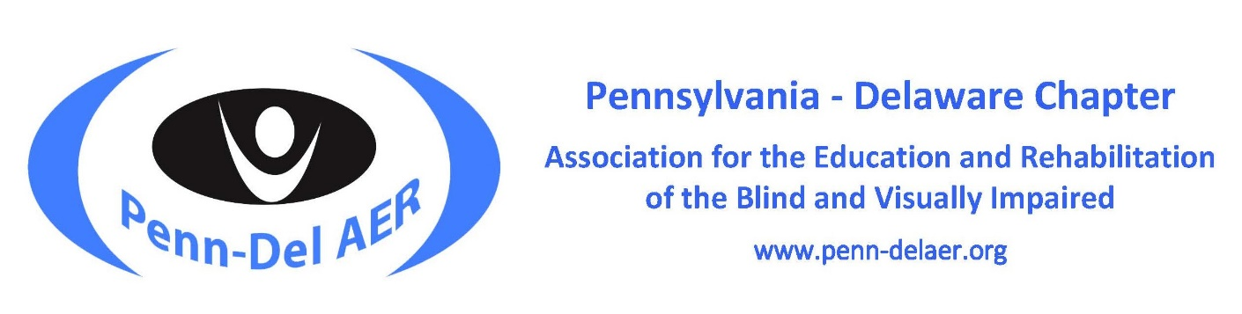
Penn-Del AER Presents the 2021 Virtual Leadership Series

Taking Charge: Restore, Refresh, Renew

A Three-Part Series on Self-Care and Resilience
In our earlier webinar series, we focused on the need for resilience as we made our way through 2020. As we move beyond those challenges, our second series focuses on strategies for recharging, refreshing, and renewing ourselves professionally and personally and on ways we can share those strategies with our students and clients.
Session Details:
- Each session is 90 minutes in length
- A certificate of attendance can be obtained upon request
- Sessions are free
- Registration is required for each session
- Request for available accommodations need to be made at least 1 week in advance

Session 1 on January 28, 2021, 4:30 – 6:00 pm EST
- Get a Move On! A Jump Start for Your New Year with Maria Lepore-Stevens
- Session 1 Webinar Registration Link
**POSTPONED** Session 2 on February 25, 2021, 4:30 – 6:00 pm EST
- Taking Care of Ourselves: Helping Us So We Can Help Others with Billy Brookshire
- **Postponed** Session 2 Registration Link
Session 3 on March 25, 2021, 4:30 – 6:00 pm EDT
- Penn-Del Rocks! Bringing the Stone Age Forward to Social Media with Maureen Army
- Session 3 Registration Link
Virtual Chapter Conference on April 21-23,2021 – Stay Tuned
The Pennsylvania-Delaware Chapter of the Association for the Education and Rehabilitation of the Blind and Visually Impaired (AER) supports professionals who provide education & rehabilitation services to people with visual impairments.
Penn-Del AER | Facebook-Penn-Del AER | Twitter-Penn-Del AER | AER

Get A Move On! A Jump Start for Your New Year

Taking Charge: Restore, Refresh, Renew — Session 1

January 28, 2021, 4:30 – 6:00 pm EST
Registration:
Click here to register for Session 1. Register no later than January 21 if requesting available accommodation.
Presenter: Maria Lepore-Stevens
Session Details:
The year 2021 offers a new beginning, so let’s jump start your year now! The January session of the Penn-Del AER self-care series will get you off your couch and back in action! Maria will guide you through a full-body circuit workout designed for you as well as for your students and clients.
In addition to an interactive workout, Maria will discuss the importance of physical activity in enhancing proprioceptive skills for students and adults with visual impairments. She will show adapted equipment that is easy to make or purchase. To top it off, she will leave you with an instructional video you can use yourself or to teach a similar activity during your sessions in Expanded Core Curriculum (ECC), Orientation and Mobility (O&M), or Vocational Rehabilitation Teaching (VRT) with students and clients.
Please come prepared with some water, comfortable clothes/shoes, and 1-2 body lengths of space. This will be a moving experience with participant participation. Please check with your physician and be sure that you are able to participate in physical exercise. If you are not able to physically participate in exercise, you are still welcome to join us for the session.
Presenter Information:
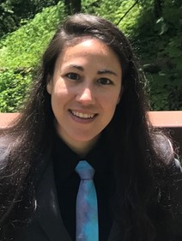
Maria Lepore-Stevens is dual certified as a COMS and a certified adapted physical educator. Maria earned her Doctorate in Educational Policy, Planning, and Administration from West Chester University, focusing on using sports programming to teach self-determination skills to youth with visual impairments. She has worked as a COMS for the Delaware Division for the Visually Impaired and the Chester County Intermediate Unit (IU) in Pennsylvania. Maria also teaches adapted physical education at Rowan University and spends her summers directing Camp Abilities educational sports camps for athletes with visual impairments in Delaware, Pennsylvania, and Arizona.

**Postponed** Taking Care of Ourselves:

Helping Us So We Can Help Others

Taking Charge: Restore, Refresh, Renew — Session 2

February 25, 2021, 4:30 – 6:00 pm EST
Registration:
POSTPONED Click here to register for Session 2. Register no later than February 18 if requesting available accommodation.
Presenter: Billy Brookshire
Session Details:
Societal change is accelerating, causing us to readjust more and more rapidly to increasing demands. The Pandemic has added yet another layer of complexity and stress to jobs that were already demanding. Many practitioners start each day depleted physically, mentally, emotionally, and spiritually.
To change this scenario, it is important to make space in your life just to “be,” to identify self-nurturing activities, and to make use of comfortable minutes. In the time we spend together in this workshop, we’ll explore options to help you take better care of yourself. The good news is that these activities don’t have to be hard, expensive, or take a lot of time, and they can be shared with your students and clients and with their families!
Presenter Information:
Billy T. Brookshire, a Past President of AER’s International Board, has over forty years of experience in rehabilitation and training and a reputation to match! He retired from the Texas Division for Blind Services where he served as Blindness Training and Development Specialist for 30 years. As the award-winning author of the book, Loving Me: A Guide to Creating and Presenting Workshops on Self-Esteem, Billy continues his passion for working with people through his private practice as a consultant and presenter of his uniquely animated workshops throughout the U.S. and Canada. He serves on several vision-field-related boards and remains a long-term member of AER’s History and Memorial Committee.
A native son of the Lone Star State, Billy grew up on a farm in Central Texas and has lived in Austin since 1977. In addition to his professional expertise, he adds to Austin’s local color as an expert sight-seeing guide and loves showing visitors the rich culture and beauty of the city. He is widely known for wearing quirky clothing, disgorging boot-loads of Texas trivia on unsuspecting bystanders, and always — ALWAYS — taking time to laugh and have fun.
Billy’s awards include: the Robert M. Lambert Award for Outstanding Lifetime Achievement in Service to People Who Are Blind and Visually Impaired from AER Psycho-Social Division in 2008; the Virgil Zickel Award for Excellence In Product Development from the American Printing House for the Blind in 2003; the Aubrey Boyd Tipps Memorial Award from Texas Association for Education and Rehabilitation in 1999; the Sammy K. Rankin Outstanding Member Award from TAER in 1995; the Distinguished Service Award In Rehabilitation from South Central Region of AER in 1993; the Arkansas Traveler in 1991; and Admiral of the Texas Navy in 1986.

Penn-Del Rocks!

Bringing the Stone Age Forward to Social Media

Taking Charge: Restore, Refresh, Renew — Session 3

March 25, 2021, 4:30 – 6:00 pm EDT
Registration:
Click here to register for Session 3. Register no later than March 18 if requesting available accommodation.
Presenter: Maureen Army
Session Details:
Join Maureen in a painting class that will bring humanity’s original art form to our future! Learn how to paint rocks, share them in your community, and use social media to share with others now and in years to come. As you create several unique painted rocks, participants will learn about the history of rocks/pebbles/stones in Human Culture around the world.
Once you’ve completed your rocks, you can keep or share your creations by hiding them in your community or anywhere you travel in the World. Our painted rocks that are found will lead the “rock hunters” to a Penn-Del Rock Painting Facebook page. This page will be created to record “finds” and “hints” to new hidden locations. Rock finds will be mapped as they occur on the Facebook page to see their travel. The Penn-Del Rocks will also be used to inform the finders of our wonderful profession in ways your imagination will help create. Come join us as we “rock on”.
Presenter Information:
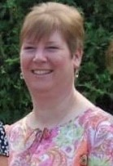
Maureen is a Blind Rehabilitation Specialist/COMS for the VA NJ Healthcare System VISOR Program. She found her career while guiding visually impaired and blind cross-country skiers in northern Vermont as an undergraduate student. Maureen attended Springfield College for her Bachelor's degree, Western Michigan University for her Master's in Blind Rehabilitation/O&M, and The Union Institute & University for her Master's in Counseling Psychology. Maureen has been a professional instructor in the field of Blind Rehabilitation for 28 years including teaching O&M, low vision, manual skills, living skills/rehab teaching, computer access training, and an O&M intern supervisor. She has worked in private, state, and federal agencies including a maximum-security prison. From the Blue Ridge Mountains of North Carolina to the Crown of Maine, Maureen has enjoyed teaching students of all ages as an itinerant, residential, and clinic-based instructor.
Maureen has also been an active Board Member of the Pillwillop Therapeutic Farm in Bristol, Connecticut, for the past 15 years. She has volunteered at the farm and taught basic American Sign Language to parents and children who garden, attend art therapy, and/or counseling. Maureen is planning a sensory garden as a future project for the trails within the farm property!

