Penn-Del AER 2021 Virtual Leadership Series
Taking Charge: Restore, Refresh, Renew
A Three-Part Series on Self-Care and Resilience
Session 3 Thursday March 25, 2021 at 4:30 pm with Maureen Army

“Penn-Del Rocks!”

Preparation and Supply List

Introduction
Art has long been a creative way of expression and a restorative therapy. Painting rocks—yes, plain old rocks— and hiding them for others to discover has become a unique viral activity, especially during the quarantines of COVID-19. This informal artform has proven to be both fun and meaningful to the painter as well as to those who discover the special messages the painted rocks carry.
On March 25th Maureen Army will guide us as we paint rocks to relax and to recharge! She will present a variety of ways to paint rocks and will share tips for acrylic painting, drawing on rocks with acrylic pens or sharpies, and acrylic pour painting. She will also help us share our works in our communities and on social media. We invite you to gather some materials and join in this relaxing self-care venture!
Preparation
- First thing to do is to decide how you would like to participate.
  - If you will be painting rocks during the session, choose the types of painting that you would like to try such as: acrylic painting, drawing with acrylic pens or sharpies, or acrylic pour painting.
  - You may also choose to observe during this session and paint later with your clients or students.
- Next, it will be necessary to collect basic supplies.
- Many of them can likely be found around your home; others can be found at art stores, general craft stores, hardware stores, and on Amazon.
- See the lists below of the supplies for each method of painting your rocks.
- Finally, you will need to set up your work area ahead of the session and wash and dry all the rocks you wish to paint.
- It will help if you pre-paint the rocks with white acrylic paint ahead of the class so they can be dry and ready to decorate.
- You can pre-paint the side you wish to decorate or paint the entire rock.

Supplies

Basic Supplies for all Art Styles:
- ROCKS—Gather different sizes and shapes. Many can probably be found around your home or on a walk. Landscape companies are also good places to find nice, smooth rocks. Wash and dry your rocks before the session.
- Large T-shirt or apron to protect your clothing
- Sheets of paper, plastic tablecloth, plastic shower curtain, or an old towel to cover painting area
- Paper towels or rags for cleanup
- Plastic gloves and mask for protection when using spray sealers
- Stir sticks or plastic knives to mix paints
- Cardboard egg cartons (not Styrofoam) with lids removed or cardboard 4-cup holders from restaurants
- Scissors
- Painter’s tape
- Dawn dishwashing liquid or Pink Soap (refer to picture below) for washing brushes
- 16 oz or larger glass jar for water
- Paper plates or plastic palettes from dollar store for mixing colors
- Elmer’s Glue or Mod Podge-type glue
- Clear paint sealer that is safe for masonry/rocks and indoor use (check Krylon, Rust-Oleum, Mod Podge)
- Sponges or nature items for textures that can give interesting textures
- Little pom-poms, googly eyes, beads, etc. if you want to jazz up your rocks!

Acrylic Painting Supplies:
- Tubes or bottles of preferred colors of acrylic paint. White paint is a must!
- Puff Paint can also be used for braille dots or other 3D effects
- Acrylic paint brushes of various sizes: medium and large for big areas; fine tipped brushes for detail; palette knives if you would like to try something different for more texture

Supplies for Drawing with Sharpies or Acrylic Pens:
- You can use multiple colors of Sharpies or acrylic paint pens (such as Niutop or other brands) available at many craft stores and from Amazon.

Acrylic Pour Painting Supplies:
- A pouring medium is necessary for acrylic pour painting. There are different types of pouring mediums, such as Flood Foetrol, that you can find on Amazon or in craft stores. Be sure that the one you choose is for pouring acrylic with acrylic. You will only need a small amount.
- A variety of small flexible cups such as Solo or Dixie cups. Be sure to have enough to provide a cup for each color you plan to use.
- Tubes or bottles of acrylic paint: White paint is necessary. You can also choose preferred colors, as well as puff paint that can also be used for 3D effects
- A disposable aluminum tray or other flat container with sides as well as a rack, such as those used for cooling baked goods, to put over the tray. You will set the rocks on the rack when you pour the paint over them.
- For a really cool effect, if you want small bubbles to pop, you can use a small amount of silicone pouring oil in the paint.

Supply Pictures

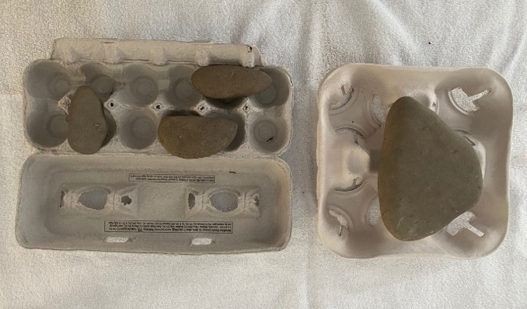

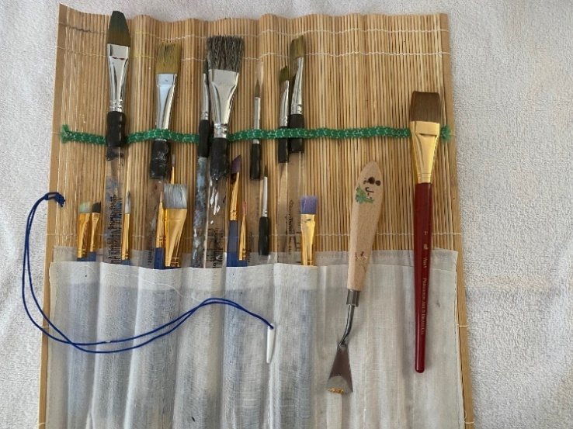
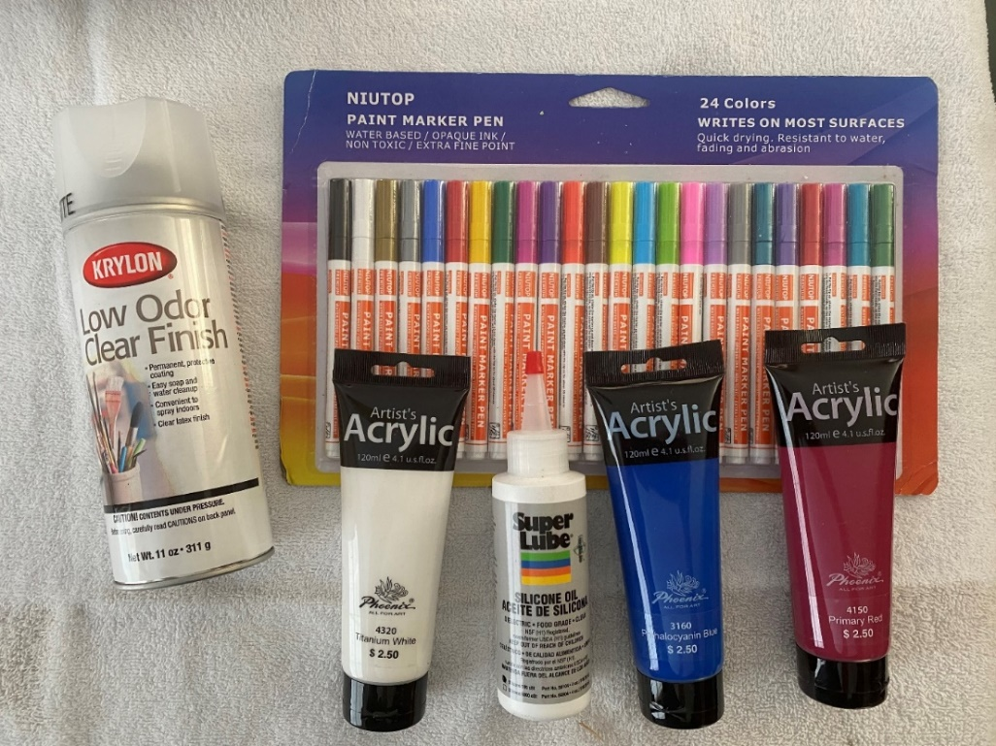

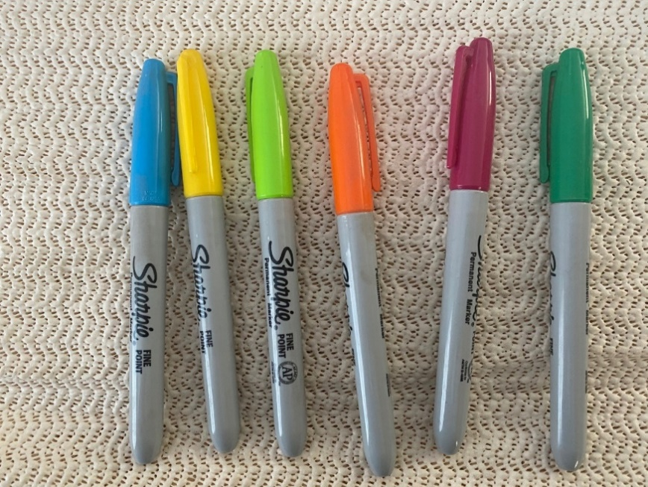

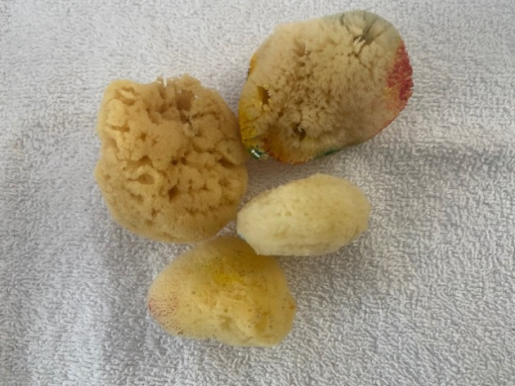

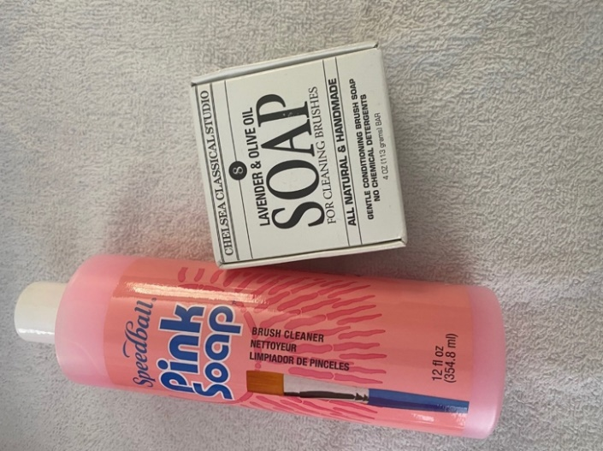
Please feel free to email Maureen Army at allicnb@gmail.com with any questions ahead of the March 25 session!

Session Registration

Let’s Rock!
The Pennsylvania-Delaware Chapter of the Association for the Education and Rehabilitation of the Blind and Visually Impaired (AER) supports professionals who provide education & rehabilitation services to people with visual impairments.
Penn-Del AER | Facebook-Penn-Del AER | Twitter-Penn-Del AER | AER

