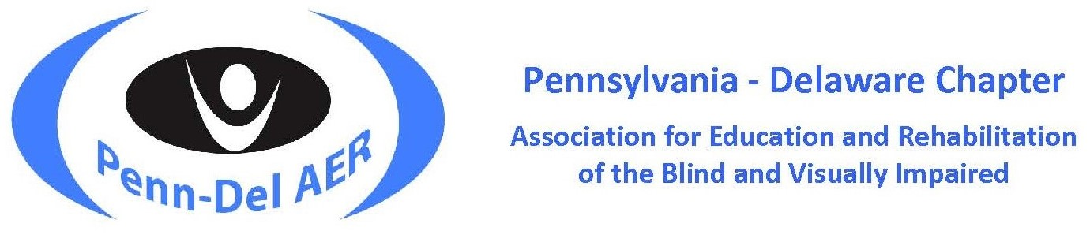

SAVE THE DATE

2024 Penn-Del AER Conference

We are happy to announce that our annual conference will be an in-person event April 24 – 26, 2024. Our nationally respected conference offers a wide range of opportunities for professionals in the field of education and rehabilitation of individuals with visual impairments. It provides experiences to enhance one’s skill set, time to share expertise and experiences, and opportunities to network with professionals in the field.

When: April 24 – 26, 2024
Where: Best Western Premier Central Hotel and Conference Center in Harrisburg, PA
Theme: Shared Stories: Magnifying Our Impact
Format: Full in-person event
Coming Soon: The Call for Presentations for sessions, posters and exhibitors will be distributed early fall.

Join us! We invite you to submit a call for presentations, call for poster, and/or register to be an exhibitor. Accept this opportunity to share your knowledge and expertise of innovative programs, creative techniques, employment strategies, research results or design in any area of our field.
The Pennsylvania-Delaware Chapter of the Association for Education and Rehabilitation of the Blind and Visually Impaired (AER) supports professionals who provide education & rehabilitation services to people with visual impairments.
Penn-Del AER | Facebook-Penn-Del AER | Twitter-Penn-Del AER | AER

